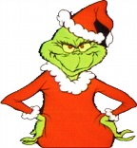**Message Outline**

*The Gospel in the Grinch:*

*I’m Sorry*

**Matthew 1:18-25**

**Intro:** Gospel themed series since summer…