 **Message Outline**

*The Gospel According to Taylor Swift: Blank Space*

**Revelation 20:1-21:8**

**Intro:** A few parting words as we close out our Swift summer series…

* *“Don’t throw out the baby with the bathwater.”* ie. don’t discard precious life with dirty water…
* Paul quoting poets of his day to point people to God’s truth (Acts 17)…
* Summer of Swift is NOT an endorsement of Swift…some “dirty water” that needs discarded, but also some precious life that needs pondered!
* Today’s song, pondering eternity…

*So it's gonna be forever  
Or it's gonna go down in flames …*

*But I've got a blank space, baby  
And I'll write your name*

* Forever or flames…but space for names? Sounds like God’s eternal offer to all!!!

**Read:** Revelation 20:1-21:8

* Revelation and confusion…

-Biblical hermeneutic: Allowing the Bible

help us understand other parts of the Bible.

-Remember genre: apocalyptic

**v.1-10—**Main views on the end times millennia:

1) ________________________

2) ________________________

3) ________________________

* Difference between dogma, doctrine, and opinion…not a heretical vs. orthodox debate.

**v.11—**“great white throne”…authority/purity!

**v.12—**“great or small”…all stand before this throne!

* “book of life” and written in Jesus’ blood (cf. Rev.3:5, 13:8, 21:27, Phil.4:3)…

**v.13-15—**The “flame” or “forever”…room on the rolls for writing your name!!!

 **Message Outline**

*The Gospel According to Taylor Swift: Blank Space*

**Revelation 20:1-21:8**

**Intro:** A few parting words as we close out our Swift summer series…

* *“Don’t throw out the baby with the bathwater.”* ie. don’t discard precious life with dirty water…
* Paul quoting poets of his day to point people to God’s truth (Acts 17)…
* Summer of Swift is NOT an endorsement of Swift…some “dirty water” that needs discarded, but also some precious life that needs pondered!
* Today’s song, pondering eternity…

*So it's gonna be forever  
Or it's gonna go down in flames …*

*But I've got a blank space, baby  
And I'll write your name*

* Forever or flames…but space for names? Sounds like God’s eternal offer to all!!!

**Read:** Revelation 20:1-21:8

* Revelation and confusion…

-Biblical hermeneutic: Allowing the Bible

help us understand other parts of the Bible.

-Remember genre: apocalyptic

**v.1-10—**Main views on the end times millennia:

1) ________________________

2) ________________________

3) ________________________

* Difference between dogma, doctrine, and opinion…not a heretical vs. orthodox debate.

**v.11—**“great white throne”…authority/purity!

**v.12—**“great or small”…all stand before this throne!

* “book of life” and written in Jesus’ blood (cf. Rev.3:5, 13:8, 21:27, Phil.4:3)…

**v.13-15—**The “flame” or “forever”…room on the rolls for writing your name!!!

 **Message Outline**

*The Gospel According to Taylor Swift: Blank Space*

**Revelation 20:1-21:8**

**Intro:** A few parting words as we close out our Swift summer series…

* *“Don’t throw out the baby with the bathwater.”* ie. don’t discard precious life with dirty water…
* Paul quoting poets of his day to point people to God’s truth (Acts 17)…
* Summer of Swift is NOT an endorsement of Swift…some “dirty water” that needs discarded, but also some precious life that needs pondered!
* Today’s song, pondering eternity…

*So it's gonna be forever  
Or it's gonna go down in flames …*

*But I've got a blank space, baby  
And I'll write your name*

* Forever or flames…but space for names? Sounds like God’s eternal offer to all!!!

**Read:** Revelation 20:1-21:8

* Revelation and confusion…

-Biblical hermeneutic: Allowing the Bible

help us understand other parts of the Bible.

-Remember genre: apocalyptic

**v.1-10—**Main views on the end times millennia:

1) ________________________

2) ________________________

3) ________________________

* Difference between dogma, doctrine, and opinion…not a heretical vs. orthodox debate.

**v.11—**“great white throne”…authority/purity!

**v.12—**“great or small”…all stand before this throne!

* “book of life” and written in Jesus’ blood (cf. Rev.3:5, 13:8, 21:27, Phil.4:3)…

**v.13-15—**The “flame” or “forever”…room on the rolls for writing your name!!!

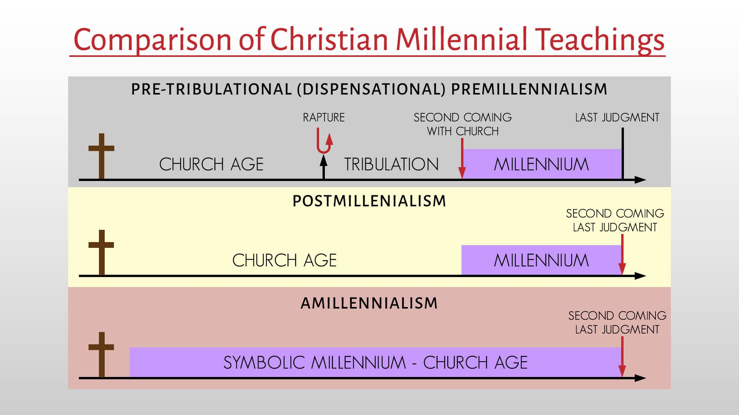

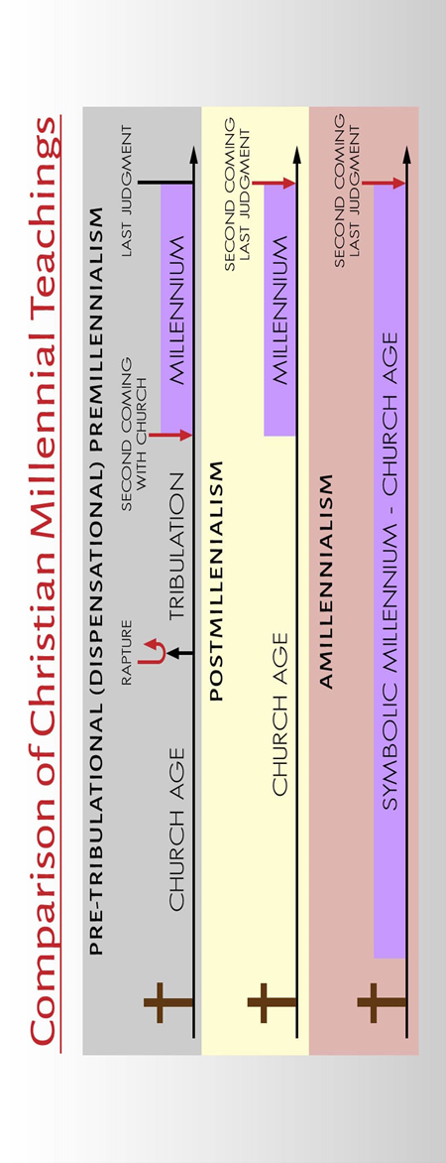



**Revelation 20:1-21:8 NIV**

**1** And I saw an angel coming down out of heaven, having the key to the Abyss and holding in his hand a great chain. **2**He seized the dragon, that ancient serpent, who is the devil, or Satan, and bound him for a thousand years. **3**He threw him into the Abyss, and locked and sealed it over him, to keep him from deceiving the nations anymore until the thousand years were ended. After that, he must be set free for a short time.

**4**I saw thrones on which were seated those who had been given authority to judge. And I saw the souls of those who had been beheaded because of their testimony about Jesus and because of the word of God. They had not worshiped the beast or its image and had not received its mark on their foreheads or their hands. They came to life and reigned with Christ a thousand years. **5**(The rest of the dead did not come to life until the thousand years were ended.) This is the first resurrection. **6**Blessed and holy are those who share in the first resurrection. The second death has no power over them, but they will be priests of God and of Christ and will reign with him for a thousand years.

**7**When the thousand years are over, Satan will be released from his prison **8**and will go out to deceive the nations in the four corners of the earth—Gog and Magog—and to gather them for battle. In number they are like the sand on the seashore. **9**They marched across the breadth of the earth and surrounded the camp of God’s people, the city he loves. But fire came down from heaven and devoured them. **10**And the devil, who deceived them, was thrown into the lake of burning sulfur, where the beast and the false prophet had been thrown. They will be tormented day and night for ever and ever.

**11**Then I saw a great white throne and him who was seated on it. The earth and the heavens fled from his presence, and there was no place for them. **12**And I saw the dead, great and

**Revelation 20:1-21:8 NIV**

**1** And I saw an angel coming down out of heaven, having the key to the Abyss and holding in his hand a great chain. **2**He seized the dragon, that ancient serpent, who is the devil, or Satan, and bound him for a thousand years. **3**He threw him into the Abyss, and locked and sealed it over him, to keep him from deceiving the nations anymore until the thousand years were ended. After that, he must be set free for a short time.

**4**I saw thrones on which were seated those who had been given authority to judge. And I saw the souls of those who had been beheaded because of their testimony about Jesus and because of the word of God. They had not worshiped the beast or its image and had not received its mark on their foreheads or their hands. They came to life and reigned with Christ a thousand years. **5**(The rest of the dead did not come to life until the thousand years were ended.) This is the first resurrection. **6**Blessed and holy are those who share in the first resurrection. The second death has no power over them, but they will be priests of God and of Christ and will reign with him for a thousand years.

**7**When the thousand years are over, Satan will be released from his prison **8**and will go out to deceive the nations in the four corners of the earth—Gog and Magog—and to gather them for battle. In number they are like the sand on the seashore. **9**They marched across the breadth of the earth and surrounded the camp of God’s people, the city he loves. But fire came down from heaven and devoured them. **10**And the devil, who deceived them, was thrown into the lake of burning sulfur, where the beast and the false prophet had been thrown. They will be tormented day and night for ever and ever.

**11**Then I saw a great white throne and him who was seated on it. The earth and the heavens fled from his presence, and there was no place for them. **12**And I saw the dead, great and

**Revelation 20:1-21:8 NIV**

**1** And I saw an angel coming down out of heaven, having the key to the Abyss and holding in his hand a great chain. **2**He seized the dragon, that ancient serpent, who is the devil, or Satan, and bound him for a thousand years. **3**He threw him into the Abyss, and locked and sealed it over him, to keep him from deceiving the nations anymore until the thousand years were ended. After that, he must be set free for a short time.

**4**I saw thrones on which were seated those who had been given authority to judge. And I saw the souls of those who had been beheaded because of their testimony about Jesus and because of the word of God. They had not worshiped the beast or its image and had not received its mark on their foreheads or their hands. They came to life and reigned with Christ a thousand years. **5**(The rest of the dead did not come to life until the thousand years were ended.) This is the first resurrection. **6**Blessed and holy are those who share in the first resurrection. The second death has no power over them, but they will be priests of God and of Christ and will reign with him for a thousand years.

**7**When the thousand years are over, Satan will be released from his prison **8**and will go out to deceive the nations in the four corners of the earth—Gog and Magog—and to gather them for battle. In number they are like the sand on the seashore. **9**They marched across the breadth of the earth and surrounded the camp of God’s people, the city he loves. But fire came down from heaven and devoured them. **10**And the devil, who deceived them, was thrown into the lake of burning sulfur, where the beast and the false prophet had been thrown. They will be tormented day and night for ever and ever.

**11**Then I saw a great white throne and him who was seated on it. The earth and the heavens fled from his presence, and there was no place for them. **12**And I saw the dead, great and

small, standing before the throne, and books were opened. Another book was opened, which is the book of life. The dead were judged according to what they had done as recorded in the books. **13**The sea gave up the dead that were in it, and death and Hades gave up the dead that were in them, and each person was judged according to what they had done. **14**Then death and Hades were thrown into the lake of fire. The lake of fire is the second death. **15**Anyone whose name was not found written in the book of life was thrown into the lake of fire.

**1** Then I saw “a new heaven and a new earth,” for the first heaven and the first earth had passed away, and there was no longer any sea. **2**I saw the Holy City, the new Jerusalem, coming down out of heaven from God, prepared as a bride beautifully dressed for her husband. **3**And I heard a loud voice from the throne saying, “Look! God’s dwelling place is now among the people, and he will dwell with them. They will be his people, and God himself will be with them and be their God. **4**‘He will wipe every tear from their eyes. There will be no more death’ or mourning or crying or pain, for the old order of things has passed away.”

**5**He who was seated on the throne said, “I am making everything new!” Then he said, “Write this down, for these words are trustworthy and true.”

**6**He said to me: “It is done. I am the Alpha and the Omega, the Beginning and the End. To the thirsty I will give water without cost from the spring of the water of life. **7**Those who are victorious will inherit all this, and I will be their God and they will be my children. **8**But the cowardly, the unbelieving, the vile, the murderers, the sexually immoral, those who practice magic arts, the idolaters and all liars—they will be consigned to the fiery lake of burning sulfur. This is the second death.”

small, standing before the throne, and books were opened. Another book was opened, which is the book of life. The dead were judged according to what they had done as recorded in the books. **13**The sea gave up the dead that were in it, and death and Hades gave up the dead that were in them, and each person was judged according to what they had done. **14**Then death and Hades were thrown into the lake of fire. The lake of fire is the second death. **15**Anyone whose name was not found written in the book of life was thrown into the lake of fire.

**1** Then I saw “a new heaven and a new earth,” for the first heaven and the first earth had passed away, and there was no longer any sea. **2**I saw the Holy City, the new Jerusalem, coming down out of heaven from God, prepared as a bride beautifully dressed for her husband. **3**And I heard a loud voice from the throne saying, “Look! God’s dwelling place is now among the people, and he will dwell with them. They will be his people, and God himself will be with them and be their God. **4**‘He will wipe every tear from their eyes. There will be no more death’ or mourning or crying or pain, for the old order of things has passed away.”

**5**He who was seated on the throne said, “I am making everything new!” Then he said, “Write this down, for these words are trustworthy and true.”

**6**He said to me: “It is done. I am the Alpha and the Omega, the Beginning and the End. To the thirsty I will give water without cost from the spring of the water of life. **7**Those who are victorious will inherit all this, and I will be their God and they will be my children. **8**But the cowardly, the unbelieving, the vile, the murderers, the sexually immoral, those who practice magic arts, the idolaters and all liars—they will be consigned to the fiery lake of burning sulfur. This is the second death.”

small, standing before the throne, and books were opened. Another book was opened, which is the book of life. The dead were judged according to what they had done as recorded in the books. **13**The sea gave up the dead that were in it, and death and Hades gave up the dead that were in them, and each person was judged according to what they had done. **14**Then death and Hades were thrown into the lake of fire. The lake of fire is the second death. **15**Anyone whose name was not found written in the book of life was thrown into the lake of fire.

**1** Then I saw “a new heaven and a new earth,” for the first heaven and the first earth had passed away, and there was no longer any sea. **2**I saw the Holy City, the new Jerusalem, coming down out of heaven from God, prepared as a bride beautifully dressed for her husband. **3**And I heard a loud voice from the throne saying, “Look! God’s dwelling place is now among the people, and he will dwell with them. They will be his people, and God himself will be with them and be their God. **4**‘He will wipe every tear from their eyes. There will be no more death’ or mourning or crying or pain, for the old order of things has passed away.”

**5**He who was seated on the throne said, “I am making everything new!” Then he said, “Write this down, for these words are trustworthy and true.”

**6**He said to me: “It is done. I am the Alpha and the Omega, the Beginning and the End. To the thirsty I will give water without cost from the spring of the water of life. **7**Those who are victorious will inherit all this, and I will be their God and they will be my children. **8**But the cowardly, the unbelieving, the vile, the murderers, the sexually immoral, those who practice magic arts, the idolaters and all liars—they will be consigned to the fiery lake of burning sulfur. This is the second death.”